INTRODUCTION
BeagleBone Black:
Beagle boards are tiny computers with all the capability of today’s desktop machines, without the bulk, expense, or noise. The BeagleBone Black is the newest member of the BeagleBoard family. It is a lower-cost, high-expansion focused BeagleBoard using a low cost Sitara XAM3359AZCZ100 Cortex A8 ARM processor from Texas Instruments. It is similar to the Beaglebone with some enhancement.
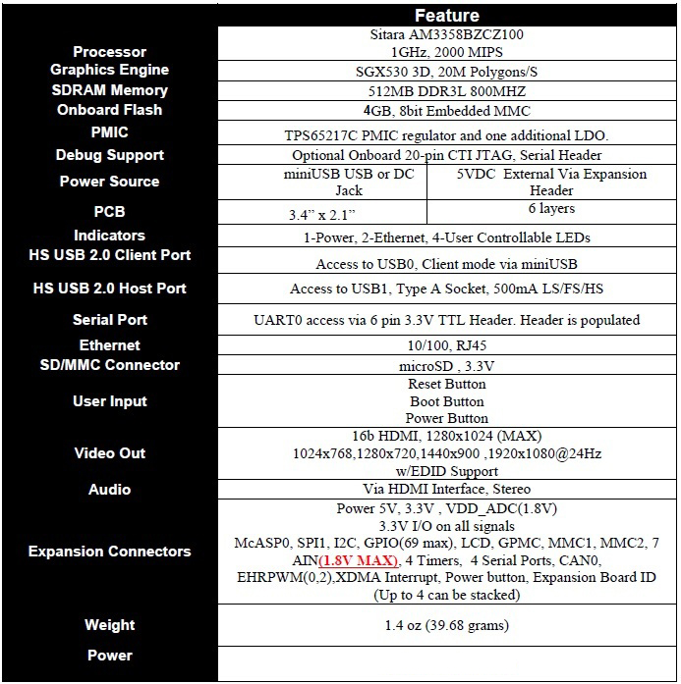
Among other differences, it increases RAM to 512 MB, the processor clock to 1 GHz, and it adds HDMI and 2 GB of eMMC flash memory. The BeagleBone Black also ships with Linux kernel 3.8, upgraded from the original BeagleBone's Linux kernel 3.2, allowing the BeagleBone Black to take advantage ofDirect Rendering Manager (DRM).
General support for this board is available from the BeagleBoard.org community.
LAYOUT/STRUCTURE:
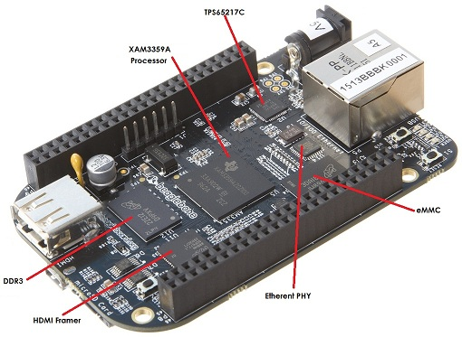
(BeagleBone Black)
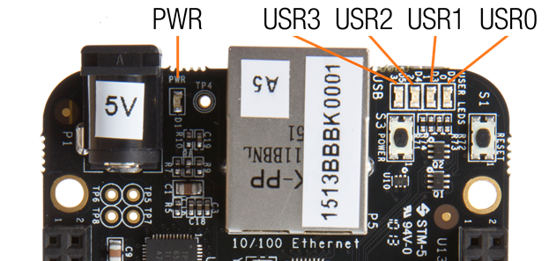

HOW TO ACCESS BBB:
STEP 1
Plug in your Beagle via USB
Use the provided USB cable to plug your Beagle into your computer. This will both power the board and provide a development interface. BeagleBone Black will boot Linux from the on-board 2GB eMMC. Either BeagleBone Black or original BeagleBone may also boot from a microSD card. Original BeagleBone is provided with a pre-configured 4GB microSD card.
BeagleBone Black will operate as a flash drive providing you with a local copy of the documentation and drivers. Note that this interface may not be used to re-configure the microSD card with a new image, but may be used to update the boot parameters using the uEnv.txt file.
You'll see the PWR LED lit steadily. Within 10 seconds, you should see the other LEDs blinking in their default configurations.
- USR0 is configured at boot to blink in a heartbeat pattern
- USR1 is configured at boot to light during microSD card accesses
- USR2 is configured at boot to light during CPU activity
- USR3 is configured at boot to light during eMMC accesses

STEP 2

Browse to your Beagle
Using either Chrome or Firefox (Internet Explorer will NOT work), browse to the web server running on your board. It will load a presentation showing you the capabilities of the board. Use the arrow keys on your keyboard to navigate the presentation.
Enter in your browser: http://192.168.7.2
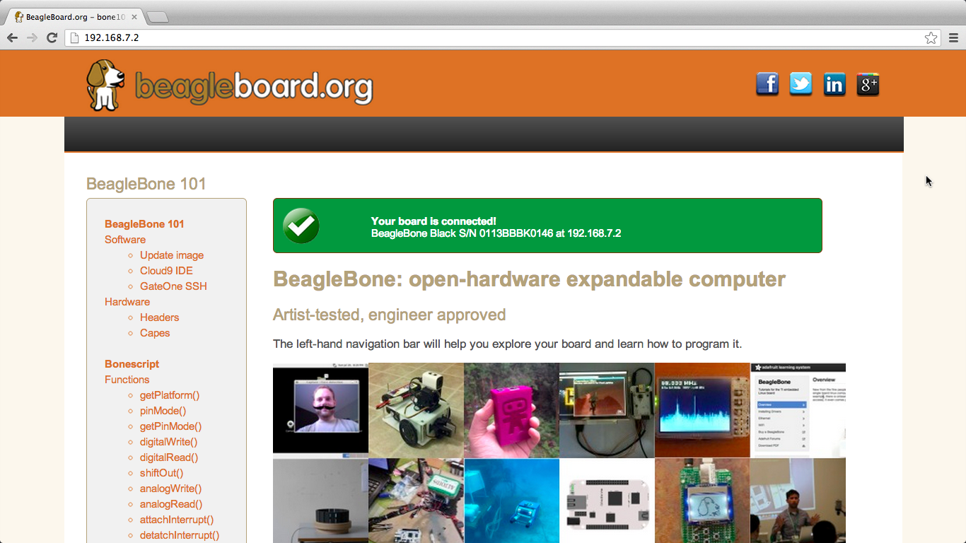

SETUP:
- Connect beaglebone black to PC with +5v supply and USB cable.
- Open terminal in ubuntu.
- Type sudo su
Type password
- Then type minicom –s
- Goto serial port setup
Press A
Change /dev/ttyxxxx to dev/ttyACM0
Press Enter
- Save setup as dfl
- Goto EXIT
- Now system will boot and then type username and password. You booted into beaglebone black.
- Type su.

Configure Network Connection with Beagle Board Hardware

You can configure the IP settings of the BeagleBoard hardware by running Linux shell commands directly on the BeagleBoard hardware.
To inspect and reconfigure the IP settings on a board that already has the new firmware, follow the procedure in this section that starts with "To configure the board to use DHCP or static IP settings".
To configure the IP settings while you are replacing the firmware on your BeagleBoard hardware,
You may need to reconfigure the IP settings if your board:
- Has unknown IP settings.
- Is unreachable using a network connection.
- Is being moved to a network or direct Ethernet connection that uses static IP settings.
- Is being moved from a network that used static IP settings to one that uses DHCP services.
When you complete the procedure in this topic, the board should be able to communicate over the network to which it is connected.
Before starting the procedure in this topic, it helps to understand the conditions under which networks use DHCP or static IP settings:
- If your board is connected to a network with DHCP services, such as an office LAN or a home network connected to the Internet, configure the board to use DHCP services. DHCP is a network service that automatically configures the IP settings of Ethernet devices connected to a network.
- If your board is directly connected to an Ethernet port on your computer, or connected to an isolated network without DHCP services, configure the board to use static IP settings.
To configure the board to use DHCP or static IP settings:
- Open a serial command line session.
- Alternatively, if your board is connected to a monitor, keyboard, and mouse, you can log in to the Ubuntu™ desktop and open a terminal window.
- Display the contents of the /etc/network/interfaces file.
Enter: cat /etc/network/interfaces
If the board is configured to use DHCP services (the default configuration), dhcp appears at the end of the following line:
iface eth0 inet dhcp
If the board is configured to use static IP settings, static appears at the end of the following line:
iface eth0 inet static
- Create a backup of the /etc/network/interfaces file.
Enter: sudo cp /etc/network/interfaces /etc/network/interfaces.backup
Enter the root password when prompted (default: temppwd).
- Edit interfaces using a editor
Enter: sudo vim /etc/network/interfaces
- Edit the last word of line that starts with iface eth0 inet.
To use DHCP services, edit the line to say:
iface eth0 inet dhcp
To use static IP settings, edit the line to say:
iface eth0 inet static
- For static IP settings, add lines for address, netmask, and gateway. For example:
iface eth0 inet static
address 192.168.1.2
netmask 255.255.255.0
gateway 192.168.1.1
Note: For static IP settings:
    - The value of the subnet mask must be the same for all devices on the network.
    - The value of the IP address must be unique for each device on the network.
For example, if the Ethernet port on your host computer has a network mask of 255.255.255.0 and a static IP address of 192.168.1.1, set:
    - netmask to use the same network mask value, 255.255.255.0.
    - address to an unused IP address, between 192.168.1.2 and 192.168.1.254.
- Exit and save the changes.
- Reboot your board for the settings to take effect:
Reboot
or
sudo shutdown -r now
- Test the IP settings by logging in to the board over a telnet session.
Note: You can use the ifconfig command to temporarily change the IP settings. Rebooting the board removes the ifconfig settings and restores the /etc/network/interfaces settings.
To change the IP settings temporarily, open a Linux command line, and enter ifconfig, the device id, a valid IP address, netmask, and the appropriate network mask. For example:
ifconfig eth0 192.168.45.12 netmask 255.255.255.0

